Project Idea Documentation

1)Project Title
Smart Property Listing Automation using Computer Vision & Machine Learning

2)Abstract
Online booking platforms such as Booking.com, Airbnb, and Agoda require property owners to manually describe rooms, facilities, and amenities during registration. This project proposes an intelligent Machine Learning system that automatically analyzes uploaded property images to generate accurate room details, facilities lists, and property descriptions. The system significantly reduces manual effort, minimizes errors, supports multi‑language onboarding, and improves listing quality.

3)Problem Statement
Property owners must manually fill long and repetitive forms describing facilities such as beds, AC, WiFi, bathrooms, kitchen items, etc. This process is:
- Time‑consuming
- Error‑prone
- Inconsistent in description quality
- Difficult for non‑technical users
As a result, many listings remain incomplete or poorly described, reducing booking chances and customer trust.

4)Proposed Solution
Build a Computer Vision based ML system that automatically analyzes uploaded room images and generates structured property information.
The system will:
- Allow hosts to select their preferred language
- Accept property photos
- Detect facilities using object detection
- Generate:
  - Property description
  - Popular facilities list
  - Room details
- Auto‑fill the listing form
- Ask the owner only for missing or non‑visual details (price, location, extra beds, etc.)

5)Objectives
- Automate property listing creation
- Support multi‑language onboarding
- Reduce manual data entry
- Improve listing accuracy and standardization
- Increase host onboarding speed
- Enhance user experience

6)Target Users
- Property owners / Hosts
- Hotel managers
- Homestay owners
- Booking platform companies
- Rural accommodation providers

7)System Overview
- Owner enters property upload page
- Selects preferred language
- Uploads property images
- Images sent to ML model
- Object detection & classification
- Deduplication of detected objects
- Structured data generation
- Web form auto‑filled
- Missing data prompted
- Owner reviews & submits listing

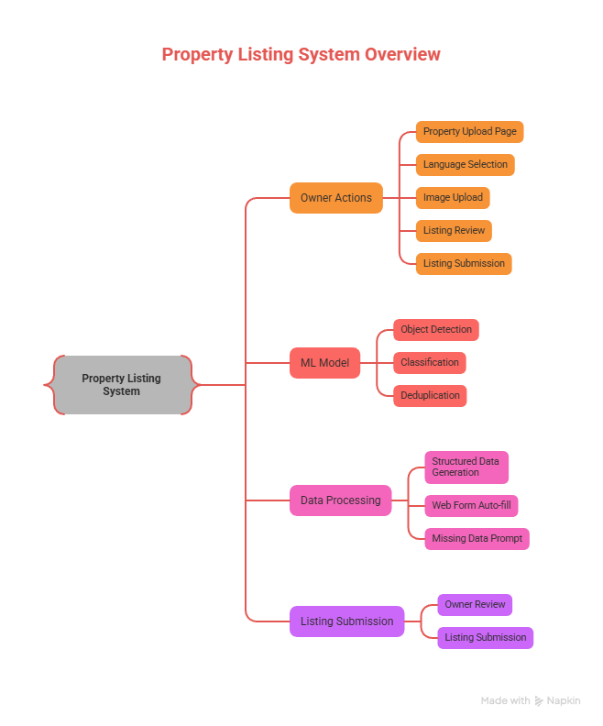

8)Detailed Workflow

Step 1 – Start
Owner opens property registration page.

Step 2 – Language Selection
Owner selects preferred language for interaction and instructions.

Step 3 – Image Upload
Owner uploads images of:
- Bedroom
- Bathroom
- Living area / gallery
- Kitchen
- Balcony
Objects include: Beds, fan, TV, WiFi router, AC, geyser, kettle, furniture, etc.

Step 4 – ML Processing
The ML model performs:
- Object detection
- Facility classification
- Room type identification
- Counting relevant items
- Removing duplicates

Step 5 – Data Generation
Generates:
- Property description
- Popular facilities
- Room details
Example output:
Beds: 2
AC: Yes
WiFi: Yes
Bathroom: Attached
TV: Yes

Step 6 – Auto‑fill Webpage
Generated data is inserted into:
- Description placeholder
- Facilities section
- Room details section

Step 7 – Missing Data Prompt
System requests remaining inputs:
- Price per night
- Location
- Extra beds
- House rules
- Check‑in / check‑out time

Step 8 – Review & Submit
Owner verifies and confirms listing.

Step 9 – End
Property listing becomes active.

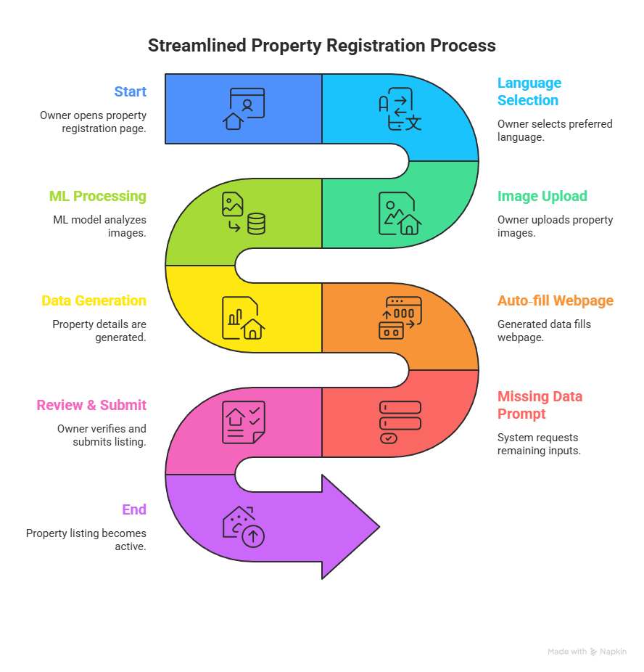

Workflow
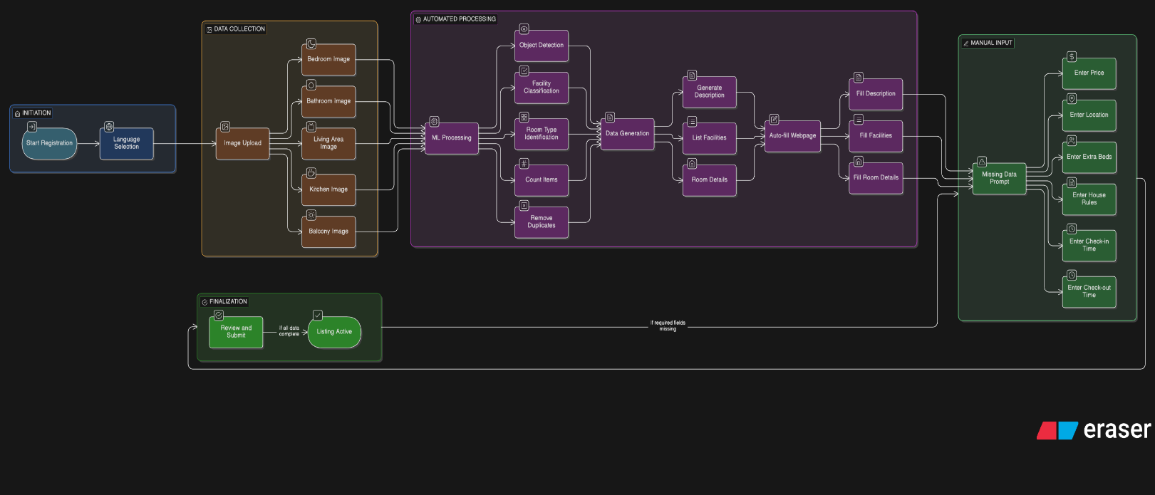
9)Features & Modules

Host Module
- Language selection
- Image upload interface
- Auto‑generated listing preview
- Edit detected information
- Submit property

ML Module
- Image preprocessing
- Object detection model
- Facility classification
- Deduplication logic
- NLP based description generator

Backend Module
- Image storage
- ML inference API
- Data validation
- Database operations

Admin Module
- Listing management
- Approval workflow
- Model accuracy monitoring

10)Technology Stack (Suggested)
Layer | Technology
Frontend | React / Next.js
Backend | Django / FastAPI / Node.js
ML Framework | PyTorch / TensorFlow
Object Detection | YOLOv8 / Detectron2
Database | PostgreSQL / MongoDB
Storage | AWS S3 / Cloudinary
Hosting | AWS / GCP / Azure

11)ML Model Design

Input
- Multiple property images

Output
Structured JSON:
{
"beds": 2,
"ac": true,
"wifi": true,
"tv": true,
"bathroom": "attached",
"kettle": true
}

12)Techniques Used
- CNN based object detection
- Multi‑label classification
- Non‑maximum suppression
- Rule‑based deduplication
- NLP for description generation

13)Database Design (Simplified)
- Users
- Properties
- Rooms
- Facilities
- Images
- Pricing
- Location

14)Advantages
- Faster onboarding
- Reduced errors
- Multi‑language support
- Better listing quality
- Scalable system
- Can expand to video input

14)Limitations
- Depends on image quality
- Cannot detect hidden facilities
- Requires large labeled datasets

15)Future Enhancements
- Video analysis support
- Automatic price recommendation
- Fraud detection
- Quality scoring
- Voice‑based input
- Mobile app integration

16)Conclusion
This project presents an intelligent automation system for booking platforms using Machine Learning and Computer Vision. It simplifies the property onboarding process, improves listing quality, supports non‑English users, and significantly reduces the effort required from hosts.

Author
Name: Shubham Mirashi
Date:21/01/2026
Email: shubhammirashi303@gmail.com
LinkedIn: linkedin.com/in/shubham-mirashi/
Github: https://github.com/Shubham1905s/Booking-Model

